A
DISSERTATION REPORT
on
Design and Implementation of AMBA-AHB based memory controller

by
RAKESH GEHALOT

2015PEV5103

Under the supervision of

Prof. RAKESH BAIRATHI

Associate professor, ECE Department
MNIT, Jaipur

Submitted in partial fulfillment of requirement of degree of

MASTER OF TECHNOLOGY

to the

DEPARTMENT OF ELECTRONICS AND COMMUNICATION ENGINEERING
JULY – 2017
© Malaviya National Institute of Technology Jaipur, 2017. All rights reserved.

DECLARATION

We hereby declare that the project work entitled (Implementation and design of AMBA-AHB based memory controller) is an authentic record of work carried out as requirements of Project for the award of degree of M.Tech in Electronics and communication engineering from Malaviya National Institute of technology Jaipur, under the guidance of Mr. Rakesh Bairathi, during July, 2016 to July, 2017).

(Signature of Student)
RAKESH GEHLOT
(2015PEV5103)

Department of Electronics and Communication Engineering
Malaviya National Institute of Technology
Jaipur

Dated: __________

Certificate

Certified that this M.tech project entitled “Implementation and design of AMBA-AHB based memory controller” submitted by Rakesh Gehalot (2015pev5103) students of Electronics & Communication Engineering Department, from Malaviya National Institute of technology Jaipur, in the partial fulfillment of the requirement for the award of Master of Technology (VLSI Design) Degree, is a record of student’s own study carried under my supervision & guidance.

Name and Signature of Project Supervisor

Designation:

Abstract

Memory controller is a part of digital system. Memory controller works as a bridge between microprocessor and memory. It is used to control the data flow (read and write) between microprocessor as master and memory as slave. Traditionally memory controllers were placed outside the microprocessor. External memory controller will introduce more latency than on chip memory controller. Nowadays memory controller is on same die as microprocessor which makes a system on chip and it reduce the latency. A design of AMBA-AHB based memory controller is presented here. The Memory controller is based on ARM Advance Bus Protocol and the concept of interleaving is used to improve the throughput of memory controller. The result of interleaving is compared with FIFO buffer [1] for same purpose. The concept of interleaving is to use memory access time or latency to access the next address from another bank of memory. The controller given here significantly improves memory access time also. The memory controller is designed and synthesized using Xilinx design tool ISE. The Verilog language is used for design purpose. Detail synthesis report is also generated by Xilinx tool which includes the maximum frequency and delay path.

Acknowledgement

I take this opportunity to present my vote of thanks to all those guidepost who really acted as lightening pillars to enlighten my way throughout this project that has led to successful and satisfactory completion of this study. I am really grateful to my HOD for providing me with an opportunity to undertake this project in this Institute and providing all facilities. I am highly thankful to my mentor Mr. Rakesh Bairathi for his active support, valuable time and advice, whole-hearted guidance, sincere cooperation and pains-taking involvement during the study and in completing the assignment of preparing the said project within the time stipulated. Lastly, I am thankful to all those, particularly the various friends , who have been instrumental in creating proper, healthy and conductive environment and including new and fresh innovative ideas for me during the project, their help, it would have been extremely difficult for me to prepare the project in a time bound framework.

RAKESH GEHALOT
(2015PEV5103)

Content
Certificate…………………………………………………………………………..iii
Abstract…………………………………………………………………………….iv
Acknowledgment…………………………………………………………………..v
List of figures……………………………………………………………………….x
List of tables………………………………………………………………………..xi
Glossary……………………………………………………………………………xiii

Chapter – 1 Introduction………………………………………………………….......1
  - Introduction…………………………………………………………….1
  - Primary memory………………………………………………………...1
    - Cache memory……………………………………………………..2
    - Main memory………………………………………………………2
      - SRAM…………………………………………………………..3
      - DRAM………………………………………………………….4
1.2.3 Read only memory…………………………………………………..4

  - Memory transfer cycle………………………………………..………………..6
    - Memory read cycle……………………………..……………….6
    - Memory write cycle…………………………………………….7
  - Main Memory and its influence on system performance………………..…….7
  - Memory controller…………………………………………………………….8
    - Double data rate memory controller…….…………………....10
    - Dual channel memory controller………….…………………..10
    - Fully buffered memory controller………….…………………10
    - Flash memory controller…………………….…..……………11
    - Direct memory access controller………….….……………….11
    - Interleaved memory.………………………..…………………12
  - Bus protocols…………………………………………..…………………….12
    - ARM bus protocol…………………….………………………12
      - APB………………………………...………………………….14
      - AHB…………………………………………………………….14
      - AXI…………………………………………………………......15
      - ACE…………………………………………………………….15
      - CHI……………………………………………………………..16
  - Terminology…………………………………………………………………..16
  - Outline………………………………………………………………………..17
Chapter – 2 Literature Review……………………………………………………...18
2.1 Objective……………………………………………….………………......18
2.2 Literature review………..…………………………….……………………18
Chapter- 3 AMBA AHB protocol………..…………………….…………………….21
3.1 Introduction…………………..……………………………………………21
3.2 AHB Signals………………………………………………………………..22
3.3 A typical AMBA AHB based microcontroller……………………………..27
3.4 Basic transfer……………………………………………………………….29
3.5 Transfer with Wait state…………………………………………………….30
3.6 Control signals……………………………………………………………...32
3.6.1 Transfer type……………………………………………………...32
3.6.2 Transfer size………………………………………………….…...33
3.6.3 Burst signals.……………………………………………….….….33
3.6.4 Response type………………………………………………….…34
Chapter- 4 Design and implementation of memory controller……………………..33
4.1 Introduction……………………………………………………………...…35
4.2 Concept of interleaving……………………………………………………..36
4.3 Finite state machine of memory controller………………………………….40
Chapter – 5 Simulation and synthesis report………………………………………..46
5.1 Simulation and wave forms…………………………………………………46
5.2 Synthesis report……………………………………………………………..54
Chapter – 6 Conclusion and future work…………………………………………….61
6.1 Conclusion ………………………………………………………………….61
6.2 Future work…………………………………………………………………61
Bibliography …………………………………………………………………………..63

List of Figures

1.1 SRAM with six transistors…………………………………………..…………..4
1.2 Memory read cycle……………………………………………...……………….7
1.3 Memory write cycle………………………………………….…………………..7
3.1 AMBA AHB based system………………………………………………………27
3.2 Multiplexed Signals in AMBA AHB system……………………………………28
3.3 Basic transfer in AHB………………………...…………………………………29
3.4 Transfer with wait state………………………………………………………….31
4.1 Memory bank distribution in flat memory………………………………………38
4.2 Memory bank distribution in interleaved memory……………………………...39
4.3 Address decoding in interleaved memory………………………………………40
4.4 Finite state machine for memory controller…………………………………….41
4.5 Block diagram of AHB based memory controller………………………………43
4.6 Memory Read cycle……………………………………………………………..44
4.7 Memory Write cycle…………………………………………………………….45
5.1 Write transaction wave forms – 1……………………………………………….47
5.2 Write transaction wave forms – 2……………………………………………….48
5.3 Write transaction wave forms – 3……………………………………………….49
5.4 Write transaction wave forms – 4……………………………………………….50
5.5 Write transaction wave forms – 5……………………………………………….51
5.6 Read transaction wave forms – 1………………………………………………..52
5.7 Read transaction wave forms – 2………………………………………………..53

List of tables

3.1 AHB signals……………………………………………………………………..24
3.2 AHB signals for multi master…………………………………………………...26
3.3 Transfer signals in AHB………………………………………………………...32
3.4 Transfer size in AHB……………………………………………………………33
3.5 Burst type in AHB.……………..……………………………………………….33
3.6 Response signals in AHB……….………………………………………………34
4.1 Memory address distribution in non interleaved memory………………………37
4.2 Memory address distribution in interleaved memory…………………………...38
5.1 Project Status……………………………………………………………………54
5.2 Synthesis Report………………………………………………………………..54

Glossary

AMBA: Advanced Microcontroller Bus Architecture is a popular bus protocol using
in system on chip and design by ARM.
AHB: Advanced High-performance Bus Protocol is developed by ARM. It is used in
high bandwidth devices.
APB: Advanced Peripheral Bus protocol is developed by ARM for low bandwidth
devices in SoC.
AXI: Advanced extensible Interface protocol.
ACE: AXI Coherency Extensions.
CHI: Coherent Hub Interface
CPU: Central processing Unit
DMA: Direct memory access
RTL: Resister Transfer Level, Hardware synthesized code used in hardware
description language.
SoC: System on chip, A large number of functional blocks on a single die.
VLSI: Very Large Scale Integration, A large number of transistor combined on a
single die.
CRC: cyclic redundancy check is an error-detecting code generally used in storage
devices and digital networks to detect changes in stored data.
SSD: solid state drive, It is a secondary storage device.
HDD: Hard disk drive, It is a secondary storage device.
RAM: Random access memory.
ROM: Read only memory.
DDR: Double data rate, It is a feature of RAM to sample data at both positive and
negative edge of system clock.
MCU: Memory Control Unit, Memory control unit is used for efficient use of
memory.
NOC: Network on chip.
IP: Intellectual property

Chapter – 1

INTRODUCTION

1.1 Introduction

Memory is a physical device capable of storing data in the form of digit 1 and 0. This data can be used for future actions.

Memory is used to store data or information for immediate use or for a long term use of data. There are two broad categories of memory in computing first is the primary memory and second is the secondary memory.

1.2 Memory hierarchy
In computer architecture design concept of discussing issues related to performance is known as memory hierarchy. The memory hierarchy is divided into different levels based on response time. Since complexity, capacity and response time are related, these levels of memory hierarchy can also be distinguished by their controlling technology and performance.
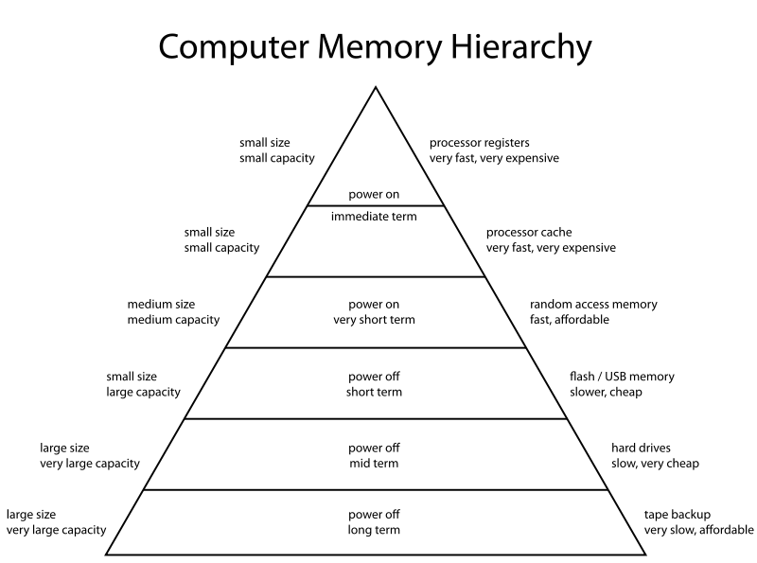
Figure 1.1: Memory hierarchy ^{[20]}

1.2.1 Primary Memory

The computer uses the memory to store the program which will be executed in near future. These programs are stored in primary memory by a computer to use frequently in near future. Primary memory also called main memory or physical memory. In computer speed of processor is higher than the memory device. To access the data from memory will lead to slow down the overall throughput. The speed of primary memory is higher than the speed of secondary memory. Computer continuous read and write data from and to primary memory.

Main memory is connected to central processing unit directly or via cache memory or registers. It has two buses one for data transfer (DATA BUS) and another for an address (ADDR BUS). The first CPU sends the address, the location where it wants to write or read data. Then CPU sends data as information if it is a write cycle or if it is a read cycle then it will retrieve the data from memory. In addition, we can use memory management unit for translating virtual address to physical address which is used as virtual memory.

1.2.1.1 Cache Memory
Cache memory is most tightly connected memory with computer processor. It is the fastest memory but also more costly than any other category of memory. This memory is used in fewer amounts inside the CPU because it is expansive. Most frequently used information is copied from main to cache for increasing the performance. There can be multilevel cache which has different locality with the processor.

1.2.2.2 Main Memory
Main memory is the memory used in the computer actively for storing the instructions of multiple programs. When CPU needs data to perform the action it will copy that data from secondary memory to main memory so that it can access it fast. A copy of that data will be there in secondary memory also.

We cannot use secondary memory as main memory because access time of secondary memory is more as compare to main memory. As we know main memory is volatile memory if power is down then data stored in main memory will not retain. Main memory is used for temporary data storage by the central processing unit. After CPU finishes executing with that data it will clear that part of data from main memory and load another required data for execution. We cannot copy all required data of all application which are currently in action because of the limited size of RAM. So to use the RAM in an efficient manner developer make their applications or program to use fewer amounts of memory by copying only needed data from secondary storage to main memory. In this method, data are swapped in between RAM and secondary storage according to requirement. This technique called swapping. Deferent algorithms are used to make room for important data and swap in main memory. Main memory also called as RAM which stands for Random access memory or Physical memory as the term used in the concept of virtual memory.

Types of main memory
There are two types of random access memory in the modern era of technology.

1.2.2.1.1 SRAM (static random access memory)
SRAM uses six transistors to store one bit of data. There is no need for any refresh circuitry to retain data in a cell because it stores the data as long as power is switched on. There is no leakage charge in SRAM. SRAM is more expansive than DRAM and it takes more area per bit than DRAM but it is faster than DRAM. In computers SRAM used as cache memory.

Static random access memory uses 6 transistors per cell. But there are 4T, 8T SRAM also available. The SRAM with six transistors is shown in figure 1.1. There are four transistors crossed coupled making inverters. Other two transistors are used for read/write operation. There are two stable states 0 and 1. In transistors, there is a layer of poly-silicon used for high resistance pull-up resistors.
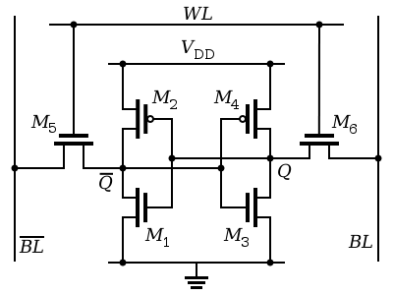
Figure 1.1: SRAM with six transistors. ^{[12]}

1.2.2.2.2 DRAM (Dynamic random access memory)
DRAM is a volatile memory used in computer and other devices. This memory uses one transistor and one capacitor to store one bit of data. Because of the only one transistor is used in DRAM. It will take less amount of area per cell as compare to SRAM. DRAM is less expensive and higher density of bit cell than SRAM. There is leakage of charge in capacitors of RAM so refresh circuitry is used to retain data in memory. There is different state for recharging the cells in RAM.

DRAM consumes a large amount of power because it needs to refresh every cell in each clock cycle. The sense amplifier is used to detect the level of charge stored in a capacitor.

1.2.3.1 Read only memory
Read only memory is a non-volatile memory use to store data for a long time in the computer or other electronic devices. Data can be stored in ROM multiple times but at slow speed. This memory is a hard wired memory such as memory made of diode or mask memory. Generally, data are written one time only inside the ROM. This is a disadvantage in many application because there can be a need for an update of codes or BIOS for security issues. But nowadays ROM can be rewritten many times.

In modern technology, there are ROMs in which data can be modified even after writing multiple times. These ROMs called programmable read only memories. This programmable ROM can be programmed multiple times but at slow speed.

ROMs are used for storing initial startup programs like BOOT sequence or factory settings in electronic devices. There are many error check algorithms are used to detect any failure in read only memory. For example: checksum.
ROM can be manufactured at low cost than the………………………… cost of a RAM. There is no write operation so ROM is simpler than RAM and has low cost than RAM. In modern computer Programmable ROM is used so that BIOS can be upgraded if there is need. But for other electronics device like keyboard, mouse the one time programmable ROM is used.

There are many types of read only memories according to its number of rewriting or technology used in fabrication.
- Mask read only memory:
MROM is a onetime programmable memory. The Information is stored at the time of manufacturing of memory. To write a bit in MROM the mask is diffused. One advantage of MROM is its cost. Per bit cost of this memory is significantly less than other semiconductor memories. But if there is any error in data writing then memory is a waste. It cannot be used again. [6]

- Programmable read only memory:
This memory is one time programmable memory (OTP). Special PROM programmer is used to write data in this memory. This programmer will destroy the fuse inside the memory to write a bit.

- Erasable programmable read only memory
This memory can be programmed multiple times. To erase the written data inside memory UV light is used. Then rewrite process begins with high voltage to write inside the memory.

- Electrical erasable programmable read only memory
This memory is similar to EPROM. But it use different way to erase the data from memory. Block by block of data can be deleted from memory. There is no need of removing the memory from CPU. Higher voltage is used to delete a bit from memory. The process of erasing memory is very slow.

1.4 Memory transfer cycle
Memory transfer cycle is transfer of address, control signals and data in signal clock cycle of system. CPU reads the instructions from memory by sending address and control signals to memory. Memory will respond to CPU by providing the required data after access time of that memory. Time from sending address and control signal to retrieving data from memory is called memory transfer cycle.

1.4.1 Memory Read cycle
In memory read cycle the CPU will first send the address of required data on address bus. After that it will send the control signals like chip select, write enable, output enable. Memory will drive the required data on data bus and assert the data strobe signal to indicate that data is valid on data bus. Figure 1.2 shows a memory read cycle.

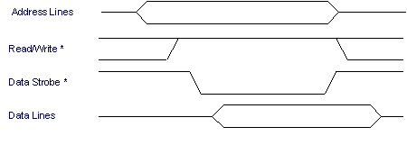
Figure 1.2: Memory read cycle ^{[13]}

1.4.2 Memory write cycle
In memory write cycle the CPU writes the data to a particular location in memory. CPU first sends the address on address bus. After that it will send the control signals like write enable and output enable. Data are driven on data bus. Memory will send data acknowledgement signal for verification of successful data written in memory. In figure 1.3 shown a data write cycle.

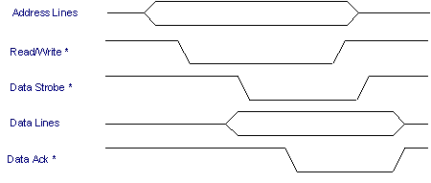
Figure 1.3: Memory write cycle ^{[13]}

1.5 Main Memory and its influence on system performance
It has been seen that by increasing computer system memory will increase the performance. But if memory is less to accommodate all required information at a time then computer will use the virtual memory. The virtual memory is a space reserved in secondary memory to simulate additional RAM in system. This concept of using secondary memory as RAM is called swapping. Method of swapping makes the system slower. The average time to access the RAM is 200ns and the average time to access secondary memory is 12000000ns. This is equivalent to a normal tasks of 3 ½ minute which will now take 4 ½ months to complete. ^{[11]}
Technically RAM does not affect the performance of computer. RAM does not have power to increase system performance. Computer uses the RAM to store the instruction of a program. Processor will search the instruction to be executed in main memory. If main memory is absence in system then processor has to search the instruction in secondary memory which will take more time to access the instruction. Large amount of RAM means more programs can fit at time in memory. All present computer system have multitasking concept where multiple programs can run at a time. We can run notepad and browser at same time.
There are many situations when a program is larger than total available RAM at that time system will store the extra amount of data into a swap file in hard disk. The required data or instruction to be executed will be loaded into main memory from swap area. This will introduce more latency in system. The transfer rate of RAM is roughly 800 MB/s as compare to hard disk which have transfer rate 30-100 MB/s. So every time computer exchange the data between swap and RAM it takes time. This will affect the performance of system. ^{[11]}

1.6 Memory controller

Memory controller is digital circuit used to manage the read and write operation with memory. Memory controller can be integrated with same processor’s same die or can a separate chip. Memory controller also called memory control unit (MCU).

In past memory controller are designed separately from processor die which has off chip latency to access the data from RAM. Integrated memory controllers are manufactured with same processor die to reduce the latency and increase the system performance. The problem in designing the memory controller with same die is it will only fit with that processor. Because of that we need to redesign the memory controller for new type of RAM.

The concept of integrating memory controller with die of microprocessor is not a new concept. In 1990s there are some microprocessors like Alpha 21066 had the memory controller integrated with same die of microprocessor. This concept is used to reduce cost of system not to reduce the latency of system. Because external memory controller will increase the cost of system. ^{[14]}

Memory controllers are designed to control the read, write, refreshing of RAM. Without refresh circuit the data stored in RAM will lose with time (time to refresh is 63 millisecond according to standard). Without memory controller CPU will spends all its time in refreshing and deciding when to read or write the data with a RAM. So memory controller allows CPU to know when it can write or read a data from RAM and it also refreshes the memory each time at negative clock cycle.

Reading and writing operation are done by selecting rows and columns of RAM. Data are access at data bus and address is provided at address bus. Data bus width can be 8-bit, 16-bit, 32-bit depends on type of RAM. Address width is also 32-bit or 16-bit depends on RAM type and processor. Number of bits in address can tell how much amount of data the bus can access. For example if the address bus is 32 bit then 4 GB of address can be accessed by this system. Sometime there is second type of address translation used by memory controller as first translation is done by memory management unit.

There can be multiple master want to access the RAM for data. A memory controller allow multiple master to get it’s turn to access the data from RAM where hand shake and bus grant signal are used to provide the access. The multiple masters can be CPU, Camera, and LCD etc.

Different variant of memory controller

1.6.1 Double data rate memory controller
Double data rate MC is used in DDR RAM. In DDR RAM data are sampled at both raising edge and falling edge of each clock cycle. DDR ram controller is more complex than simple ram controller because of sampling data at both negative and positive edge. But have advantage of transferring data at double speed than simple ram controller.

1.6.2 Dual channel memory controller
Dual channel memory controller is used where we have one RAM but multiple masters are accessing the RAM parallel which needs multiple channels for data transfer. This will increase the bus bandwidth. We can add more channels to increase the bandwidth but there is issue, we need to maintain the length of every channel at same size so that latency cannot affect the operation of multiple accesses in parallel. So it’s more difficult to increase number of channel because it will introduce the line capacitance and wire count.

1.6.3 Fully buffered memory controller
Fully buffered memory controller are used where buffer is placed at each memory module unlike simple memory controller parallel link in buffered memory controller serial link is used for data transfer this will decrease the number of wire used in bus. Because of less wire used area requirement to memory controller will also be less this will help to accommodate more memory controller on board. But latency will also increase to access the data parallel instant of serial.
Then at the master side memory controller will convert the serial link to parallel link.

1.6.4 Flash memory controller
Nowadays many flash devise are used for large data transfer like USB pen drive, camera, mobile, memory card etc. Flash memory controller is used in flash memories to transfer the large amount of data. Flash memory is generally slower than RAM to access the data so this will increase the latency in CPU. So memory controller is the solution for it.

1.6.5 Direct memory access controller
Direct memory access is the concept of accessing the RAM (read/write operations) without interpreting the CPU for each read and write. Without DMA to access the data from RAM CPU will spend its all-time in reading and writing the data and cannot get the bandwidth for other work. So DMA will help CPU to focus on other work while it will handle the data transfer with RAM without interrupting again and again. CPU will first initiate the data transfer sequence and then gives command to DMA to transfer the whole data. DMA will start transferring the data to ram to other place. After DMA finishes it will interrupt the CPU to tell the data transfer is finished. This will give more bandwidth to CPU for other important tasks.

Direct memory access has many applications in network cards, graphic cards, disk drive, sound cards and cameras. DMA also used in intra chip data transfer. Computer which has DMA channel can transfer data at minimum overheads with processor then computer without DMA channel. Using DMA data can be transferred from memory to memory without including the processor.

In typical on chip system and embedded systems, the bus architecture is a complex system used to connect all functional blocks like AMBA AHB protocol. There are two types of components in AMBA AHB master and slave. A typical slave can be memory chip or other peripherals. A master can be a processor or other controller like DMA controller. A DMA will use interface for transaction between memory and system without disturbing CPU.
A system which needs to transfer large amount of data to or from system, like network devices can be considered as master and salve. AHB do not support tri state buses or single bus for both directions.

1.6.6 Interleaved memory controller
In interleaved memory controller memory is organized in multiple memory banks and each bank is accessed pipeline way. It will improve the overall throughput of data transfer. Memory can be interleaved with n-ways if we have n banks of memory.
If there is n number of memory banks are present then memory location A will be at memory bank A/n. In memory interleaved way each consecutive address is at different memory bank. For example if we have four memory bank then memory address 00 will be at bank 0, memory address 01 will be at bank 1, memory address 10 is at bank 2 and memory address 11 is at memory bank 3.

1.7 Bus Protocols
Bus protocols are set of rules used to transfer the data between multiple devices in efficient way. Every bus protocol has some control signals, data bus, address bus. Generally bus protocol need to perform read and write operations between different devices.

1.6.1 ARM bus protocol
The ARM Advanced Microcontroller Bus Architecture (AMBA) is an open Source bus protocol used in system on chip for connection and management of functional block. ARM AMBA is designed for multiple master and slave configuration of efficient communication for data transfer. This bus protocol used in microcontroller for accessing the memory and many other peripherals. Nowadays AMBA is very popular bus protocol used on different range of SOC and Application specific ICs for example smart phones, cameras, embedded systems etc.

ARM AMBA was first developed by ARM in 1996. There are many AMBA protocols used in system on chip. The first AMBA bus protocol is Advanced Peripheral Bus (APB) and Advanced system bus (ASB). AMBA version 2 is introduced in 1999 which includes AMBA High performance Bus (AHB) in which signal raising edge is used. The AMBA version 3 protocol is introduced in 2003 which is a third generation of AMBA protocol. This generation also includes Advance Extensible Interface Protocol (AXI) and Advance Trace Bus (ATB) for debug and trace solutions. The AMBA version and AXI version 4 is introduced in 2011. ^{[16]}

In system on chip there are number of components are design as a block to increase the portability and reuse of those functional blocks. Now to connect those large number of blocks needs a good algorithm or protocol for communication in between them. AMBA bus protocol gives solution for interfacing these functional blocks.
Features of AMBA protocol:
• Facilitate right-first-time development of embedded microcontroller products with one or more CPUs, GPUs or signal processors.
• Be technology independent, to allow reuse of IP cores, peripheral and system macro cells across diverse IC processes.
• Encourage modular system design to improve processor independence, and the development of reusable peripheral and system IP libraries.
• Minimize silicon infrastructure while supporting high performance and low power on-chip communication. ^{[17]}

In Advanced Micro controller Bus Architecture design there are one or more microcontrollers as a master along with multiple salve devices like RAM, ROM, external memory, DSP, other peripherals like UART, USB, I2C, PCI are connected according to AMBA specification.

Main motive of ARM bus protocol is to develop an efficient and standard way for interconnecting the functional block with reusability capability in different design. ARM AHB (Advanced High performance) or ASB (Advanced System Bus) protocol are used for higher speed functional block like processor and an APB (Advanced Peripheral Bus) protocol is used for low speed device like peripherals for example slow RAM, UART etc.

AMBA bus protocols are introduced first time in 1996 by ARM. The evolution of AMBA protocol till now the latest version is AMBA 5 protocol. ^{[17]}
Following are the most popular AMBA protocols used nowadays and specification of these protocols can be downloaded from ARM official website for free.

1.7.1.1 APB (Advanced Peripheral Bus)
The Advanced Peripheral Bus (APB) is used for connect to slow peripherals like RAM, UART etc. In this protocol no pipeline is used. This protocol used as bridge between fast processor and slower peripheral devices. Latest version of Advanced Peripheral Bus is APB 2.0 and available at ARM official website.

1.7.1.2 AHB (Advanced High-performance Bus):
The Advanced High-performance Bus (AHB) is used with higher bandwidth devices like processor. For example it can be a fast memory or DMA. AHB have many features for example burst mode data transfer, protection, master lock for bus, user privilege mode, split mode multi master support etc.
There is also we can find simpler AHB version AHB-lite. This protocol also can be found at ARM official website. The latest version is AHB 5.0. ^{[17]}

1.7.1.3 AXI (Advanced Extensible interface)
The Advanced Extensible interface (AXI) is most advance protocol which is more complex than AHB protocol. It is used for low latency and high bandwidth interconnects. AXI protocol don’t us shared bus unlike AHB there is point to point interconnection between multiple masters. AXI also have many features like burst mode, separate read write, split mode etc.
a. AXI-lite protocol is a simplified version of AXI protocol and it will not support burst transfer of data.
b. AXI-stream protocol is another type of AXI protocol that supports only streaming of data from master to slave. In this protocol there is no separate read and write unlike a AXI-lite or full AXI. Multiple data streams can be transferred across mater and slave. And we can use interleaving method also for that.
The specification of full AXI and Lite AXI can be downloaded from ARM official website for free.
For AXI stream there is another website to download specification given below. ^{[17]}
http://infocenter.arm.com/help/topic/com.arm.doc.ihi0051a/index.html

1.7.1.4 ACE (AXI Coherence extension)
AXI Coherence extension protocol is an extension of AXI4 protocol. It is used in multicores which have cache also in same chip. In this protocol as it is extension of AXI the read and write of data channels by introducing separate snoop address, snoop response and snoop data channels. ^{[17]}
Specification of this protocol can also be found at ARM official website for free.

1.7.1.5 CHI (Coherent Hub Interface)
The ACE protocol is an extension to AXI to support coherent interconnects.
In ACE there is need of large number of wires with added channels for use of signal level communication between master-slave and interconnects. This protocol also works efficiently for small coherent clusters for example mobile system. CHI protocol is introduced in AMBA version 5 as a complete redesign of AXI Coherence extension protocol for large number of coherent clusters on system on chip like server SoC designs. CHI uses packets as a message and implements protocol/physical/link layers based communication. This protocol is currently not freely available. ^{[17]}

1.8 Terminology
Defining some important terms.
1.8.1 Interleaving
Interleaving is way of increasing the system bandwidth by accessing the memory banks simultaneously. This will significantly reduce the latency of memory.

1.8.2 Burst
Burst is the sequence of similar or consecutive data transfer in a single go without any interrupt.

1.8.3 Protocol
Protocol is a set of rule defined for a design. This will increase the portability and reusability of that design.

1.9 Outline
Chapter -2 is literature review. This chapter is study of AMBA AHB based memory controller in which buffer (FIFO) used. In chapter-3 AMBA AHB protocol is discussed. In chapter-4 the memory controller is designed and implemented. Chpater-5 is simulation and results. Chapter-6 is conclusion and future work.

Chapter – 2

Literature Review

2.1 Objective

The objective for reviewing the literature is to find a method to improve the memory controller. Here it is tried to improve the performance of memory controller in term of area and latency and make the design more portable and reusable with different type of master and salve in vast area of system on chip. Constrains are area, speed/latency and power. All three constrains are in trade off situation. AHB protocol is most popular bus protocol nowadays used in system on chip. This protocol will make the design portable and reusable at different functional blocks. This will also reduce time to market because of already available verification IPs for the same.

2.2. Literature Review of memory controller

Memory controller is an intermediate device for processor as a master and memory as a slave. It will help processor to communicate with slow memory. Memory controller will take commands from master and decode it in readable format which can be understood by slow memory. For example consider a real time system TV setup box used for scanning channels, decoding video and audio streams. It will then convert these signals to TV signals for output at monitor and speakers. It will also receive IR signals from remote control and according to signal it will change the channels and volume. If these all process will not happen within the time limit then it will generate audible noise. This noise is not acceptable so this is important for a system to respond fast where it needs. Nowadays these all systems are not separate chips or boards but these all are integrated on a single die which is called system on chip. In this system there can be many processor, memories, input output devices, communication RF devices etc. ^{[1]}

In recent years the performance of microprocessor is increased significantly, it has become important to support these high performance systems to achieve full bandwidth of system. The memory controller is part of system and it controls the memory data transfer. ^{[2]} In FIFO based memory controller the processor need to wait for data to arrive from slow memory. It will introduce the latency in system. Comparing with old simpler memory controller where data are sending one by one this is a bottleneck condition because master works at higher frequency than the memory. But in AHB based memory controller there is feature of burst mode which will send contiguous data in a single burst. AHB also have error handling features, split mode, protection mode, bus lock etc. ^{[3]}

Nowadays systems are made in different functional blocks and they are integrated on a board. These blocks are called intellectual property (IP). These IPs need to connect using bus protocol which should not affect the functionality of IP. Now with standing memory device is slower than processor which will degrade the performance of processor. Day by day speed of processor is getting increase. But the improvement in memory is not matching with the performance of processor. Memory controller is responsible for communication between memory and processor. The challenge is interfacing memory controller with RAM in an efficient manner with less foot print in SoC and minimum latency in system. There is need of an efficient way for communication between memory and processor. The solution for this is to make an efficient memory controller which can also be used with wide range IPs. This will lead to make an AHB based memory controller. The FIFO based memory controller uses the buffer to store data and commands in FIFO and wait for raising edge of memory clock cycle to complete a transaction. This idle or wait is cause for system latency. ^{[4]}
There are many approaches are used to design memory controller for example Buffered memory controller and memory controller with interleaving concept.

Chapter – 3

AMBA AHB Protocol

3.1 Introduction

The Advanced microcontroller bus architecture is an open source bus protocol used to interconnect and manage multiple functional blocks in system on chip. It is most popular protocol used in system on chip and application specific designs nowadays. In system on chip there are large number of functional blocks like processor, memories and peripherals. These all functional blocks should meet required constrain like area and speed. Solution is to use a good connectivity protocol like ARM AHB. AMBA AHB protocol is designed for high bandwidth synthesizable system. ^{[5]}

AMBA is introduced in 1996 by ARM. The first AMBA bus was advanced system bus and advance peripheral bus. After that in 1999 the second version came, AMBA version 2 which have high performance bus which is a single clock edge protocol. After this in 2003 ARM developed AMBA version 3 which have AXI and ATB bus protocol which have even more bandwidth than AHB. In 2010 AMBA version 4 came. In 2013 AMBA version 5 came. These protocols are nowadays used for wide range of 32 bit system. We can find all these protocol available at ARM official website for free. ^{[5]}

3.2 AHB signals

In AMBA all signals have naming convention to make it more readable and distinguish between other AMBA protocols. This will also help while reading and analyzing the wave form of simulation results for input and output. In naming convention each signal have a letter for that protocol. For example

AHB: H
ASB: B
APB: P

A lower case letter n in the signal name indicates that the signal is active low signal otherwise signal name is always in uppercase letters.
Test signals have a prefix T regardless of the bus type.

H prefix indicates that it is AHB signal. For example HBURST, HSIZE, HTRANS etc.
These signals are active high signals. HRESETn is active low signal because it includes the lower case n letter in signal name.

The following signals are AHB signals.
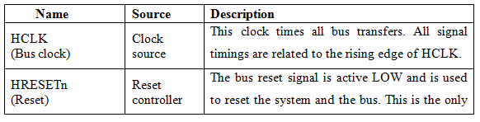
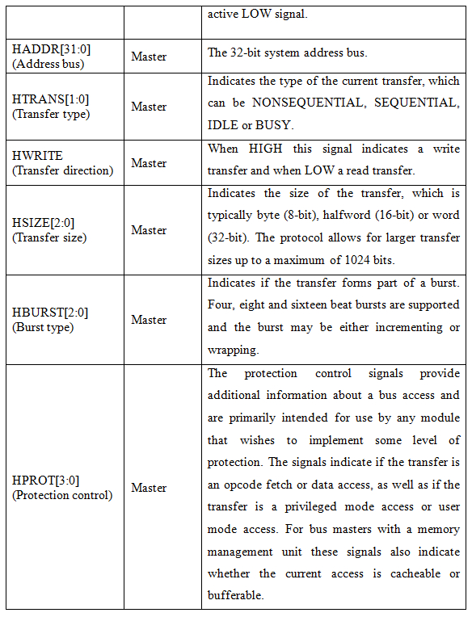
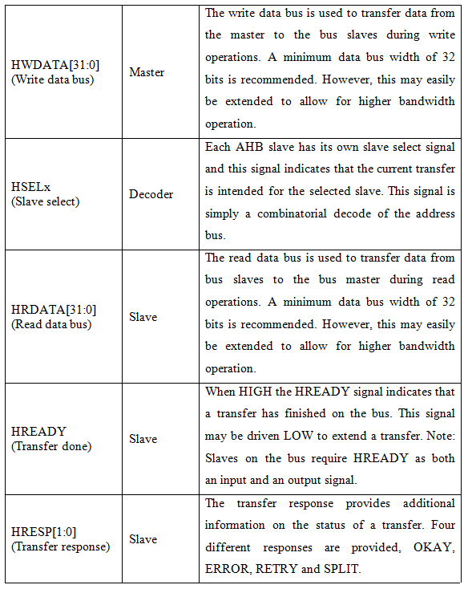
Table 3.1: AHB signals ^{[5]}

AHB also supports multiple bus masters for that extra signals are require for communication between these masters. There are many arbitration signals which are point to point. Suffix x indicates that this signal is related to master or module x. For example

There will be a number of HBUSREQx signals in a system, for example HBUSREm1,
HBUSREQm2 and HBUSREQm3 related to master 1, master 2, master 3 respectively.

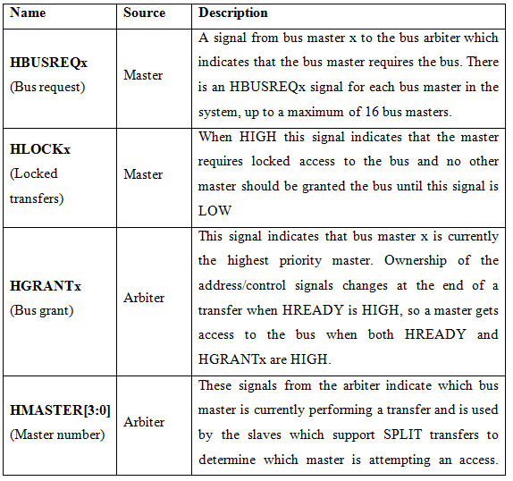
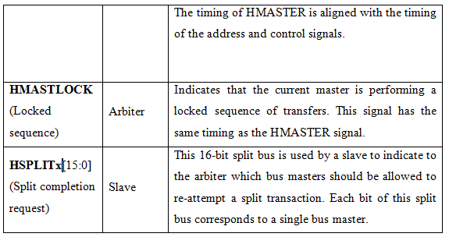
Table 3.2: AHB signals for multi master ^{[5]}

AHB is a new generation bus protocol used to work with high speed processor as well as with slow memory also for communication. For slow device we use AMBA APB protocol over the AMBA AHB protocol. This will work as bridge between higher bandwidth devices and low bandwidth devices. There are lots of features of AMBA AHB which support for higher frequency system.
Features AHB supports
- Burst transfers
- Split transactions
- Single cycle bus master handover
- Single clock edge operation
- Non-tristate implementation
- Wider data bus configurations (64/128 bits).

3.3 A typical AMBA AHB-based microcontroller

A typical AMBA AHB based microcontroller system is shown in figure. Which consist of high bandwidth memory interface, high frequency ARM processor, on chip RAM, DMA bus master, a bridge between slow memory and high speed blocks, UART, Keypad, Timer, external RAM and ROM.
.
Figure 3.1: AMBA AHB based system ^{[5]}

Bus in AMBA AHB there is multiple master are connected with slaves via multiplexer, arbiter and decoder. Multiplexer is used to connect multiple masters with multiple slaves. Arbiter will decide which master should send the address and control signal which indicates the transfer they want to perform.
Master should assert bus request before send address and command signal. If bus is available then arbiter will grant the bus to that master for transfer. Otherwise master will wait for bus grant signal.

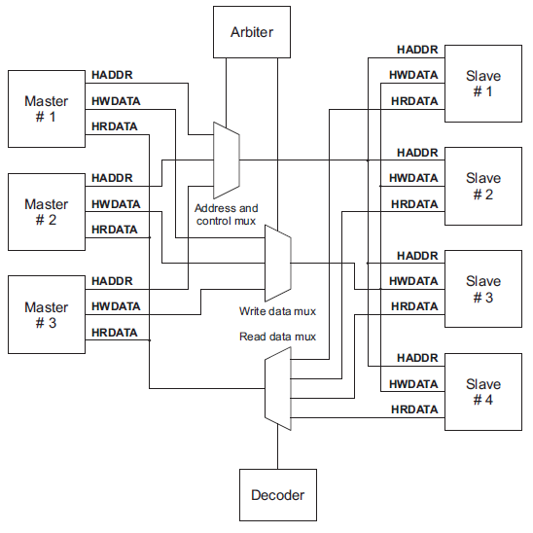
Figure 3.2: Multiplexed Signals in AMBA AHB system ^{[5]}
A decoder in system is used to controller the multiplexer for read and response of slave involved in data transfer. Control signal and address provides the information about which slave should receive the data. These signals also have information about size of transfer, type of burst etc.
There are two data bus one write data bus transfer the data from master to slave and another read data bus read data from slave and transfer it to master.
Every transfer consists of:
- An address and control signals.
- One more cycles for the data.
The address cannot be extended so all slave should sample the address at every clock cycle. We can extent data cycle by HREADY signal. When HREADY is low then this is a wait state allow slave extra time to sample the data in next clock cycle.
3.4 Basic transfer
In AHB the master will start transaction after bus is granted to it. Master will first send the address and then data in second cycle or after wait if HREADY is low. So there are two sections one is address phase and another is data phase.
Figure 3.3: Basic transfer in AHB ^{[5]}

The simple transfer without wait state
- Address and control signals are send by master after raising edge of HCLK.
- The slave sample these signal at next raising edge of HCLK.
- After sampling the address and control signal salve will generate the response according to those singles and send it to HRESP bus.
- If slave is busy it will send HREADY low to master to extent the data phase.

3.5 Transfer with wait state
In AHB if slave is with other task then it will send the HREADY low. This is the indication for master to wait for one cycle. Master will extend its transfer with repeated address and control signals.

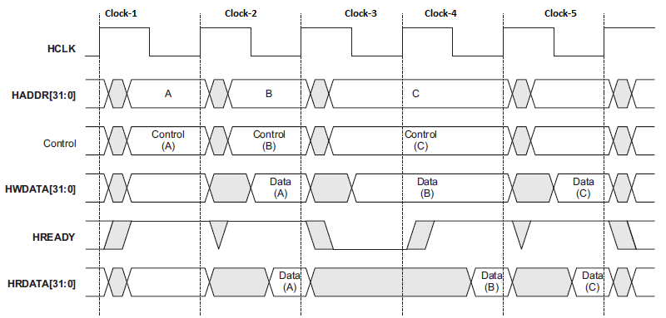
Figure 3.4 Transfer with wait state ^{[5]}

- First address A is send by master a raising edge of HCLK. In next clock slave will sample the address and control signals. If it is a read transfer then data will be read by master in this cycle otherwise data will be written in slave.
- After that address B will be sampled by slave with control signals. Slave will sample the address but there is busy signal asserted by master so slave will assert HREADY low indicating master to extend its transfer for next clock (clock-4) also.
- So data will be provided in next clock (clock-5) after HREADY is high.
- Address C will be sampled by slave in next clock cycle (clock-4) and further next cycle (clock-5) data will be sampled by salve without any wait state.

3.6 Control Signals
3.6.1 Transfer Type
In AHB protocol transfer sends with transfer type which will be sampled by slave for indication of burst finish or wait state or idle state. There are four types of transfer.
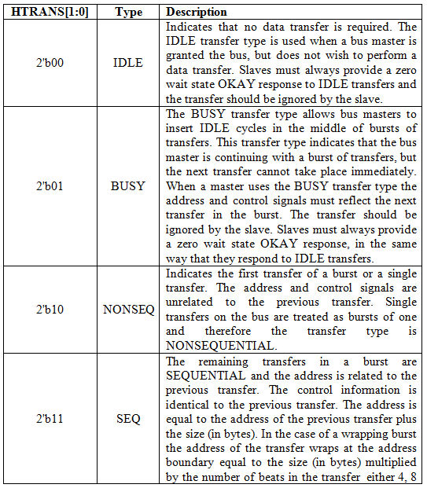
Table 3.3: Transfer signals in AHB ^{[5]}
3.6.2 Transfer Size
Transfer size indicates the size of transfer or significant data on data bus. This is 3 bit long.
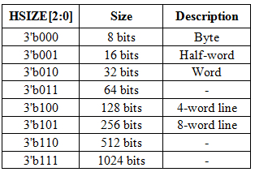
Table 3.4: Transfer size in AHB ^{[5]}
3.6.3 Burst signals
In burst transfer data will be sent in a continuous burst. This signal is 3 bit long. In table 3.5 it is shown the burst type.
Wrapping burst: In wrapping type burst the address will wrap at a particular address when boundary reached.
Incremental burst: In incremental burst will finish after number of beats completed. The address of all beats is sequential.
Table 3.5: Burst type in AHB ^{[5]}
3.6.4 Response Type
During a transfer the slave sends the response signals to indicate success or failure of transfer. This is 2 bit long signal.
This signal name is HRESP [1:0].
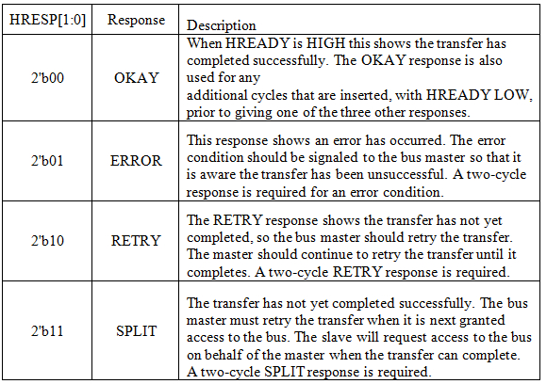
Table 3.6: Response signals in AHB ^{[5]}

Chapter - 4
Design and implementation of Memory controller

4.1 Introduction
Memory controller is small digital device which controls the data transfer between two systems. This can be separate digital chip or can be embedded with other circuit on same chip. If a memory controller is on same die then it is called integrated memory controller. The reason to use on same die is to reduce the data transfer latency between master and salve. A master can be a typical processor and a salve can be a memory for example RAM or ROM. In computers the memory controller is at North Bridge of mother board. This is now replaced with integrated memory controller used with CPU to reduce memory latency. But this also make it same type of memory depended controller which need to redesign the controller for new technology memory. ^{[14]}
Memory controller generally handles the read and write of data with a memory which can be an internal memory or external memory. The speed of memory can different from speed to processor which will make it difficult to design. DRAM controller need to refresh memory in every clock cycle which will allow processor to focus on more important task. Otherwise processor will spend its all time with accessing and refreshing the memory. To access the memory we need to select memory chip according to address and control signals. Then memory will decode it to rows and columns for particular byte or depends on width of data bus. There can memory response for telling that data is written successfully or there is an error while writing data to that address for example if it is ROM address then data cannot be altered or there can be an address which is not connected to ant memory device.

4.2 Concept of interleaving
Main memory is typically divided in series of memory banks. The number of banks is in the range of power of 2 in the most of system. Access a data from flat memory is requires time equal to the memory bank access time. If we access the memory banks simultaneously then bandwidth can be increase by number of memory bank and speed to accessing single data from one bank. If there is K number of banks then K request can be send simultaneously to memory bank. Here K is 2^{n}. ^{[18]}
For example if there is two banks in memory. If interleaving is not used then we first access the data from first address and then we send second address to memory. This will introduce the latency in system. If we use interleaving then data can be accessed simultaneously from bank while another bank is preparing data. This will increase the bandwidth of system and reduce the latency. Addresses are continuously asserted with raising edge of system clock to memory banks simultaneously so each bank will receive the address at different clock and provides the data after memory clock cycle.
Comparing with old simpler memory controller used in past where data are sending one by one this is a bottleneck condition sometime because master block is work at higher frequency than the memory. But in AHB based memory controller there is feature of burst mode which will send contiguous data in a single burst. AHB also have error handling features, split mode, protection mode, bus lock etc. Combining AHB with interleaving will significantly improve the performance of system.

However if there is 32 bit for addresses then we can access 4 GB of memory location which is a large amount of memory. In past when CPU only support less than 4 GB of location then we need to send a single back to CPU for invalid address. In this project this is handled as error for AHB master.
Let's assume that our CPU can only access 8K of RAM. The amount memory is quite small, but makes it easy to illustrate the concept of interleaved memory.

Memory address divided in non-interleaved system.
Bank-0 | Bank-1 | Bank-2 | Bank-3 | Bank-4 | Bank-5 | Bank-6 | Bank-7
0 | 1024 | 2048 | 3072 | 4096 | 5120 | 6144 | 7168
1 | 1025 | 2049 | 3073 | 4097 | 5121 | 6145 | 7169
… | … | … | … | … | … | … | …
1023 | 2047 | 3071 | 4095 | 5119 | 6143 | 7167 | 8192

Table 2.1: Memory address distribution in non interleaved memory

To find the bank for an address

If address is A and number of bank is N, then bank number:-

Bank Number = A / 1024

Flat memory distribution: In this memory address are continuous in a memory bank.
Figure 4.1: Memory bank distribution in flat memory ^{[18]}
Interleaved memory distribution: In this memory address is alternative in both memory banks. This is a two way memory interleaving.
Memory address divided in interleaved system.

Bank-0 | Bank-1 | Bank-2 | Bank-3 | Bank-4 | Bank-5 | Bank-6 | Bank-7
0 | 1 | 2 | 3 | 4 | 5 | 6 | 7
8 | 9 | 10 | 11 | 12 | 13 | 14 | 15
… | … | … | … | … | … | … | …
8185 | 8186 | 8187 | 8188 | 8189 | 8190 | 8191 | 8192

Table 2.2: Memory address distribution in interleaved memory

We divided this 8K memory in 8 banks. The address is accessible from A[0] to A[8192].

To find the bank for an address

If address is A and number of bank is N, then bank number :-

Bank Number = A % N

For example address 123 will be in bank 123 % 8 = Bank-3.

Figure 4.2: Memory bank distribution in interleaved memory ^{[18]}

Figure 4.3: Address decoding in interleaved memory ^{[18]}

In interleaved the chip select logic is decoded using LSB of address bus. So that alternative address is spread over different memory bank. Even addresses are in memory bank-0 and odd addresses are in memory bank-1. There can be more number of memory banks like 4, 8 or 16. Where the memory latency can be hide by using interleaving where time to access is less than the one clock cycle of system clock multiple by number of banks.

4.3 Finite state machine of memory controller
Finite state machine for memory controller based on AHB and concept of interleaving is designed. FSM is the heart of memory controller. It will change the state according to data, address and control signal send by master and memory. After receiving these all signal it will generate appropriate responses.
There are total six states in memory controller. Concept of interleaving introduced with AHB bus protocol. AHB master will send a transaction to memory controller to process and provide required information and data. Memory controller will change its state according to that transaction. If there is not transaction then memory controller will be in idle state and sends okay response.

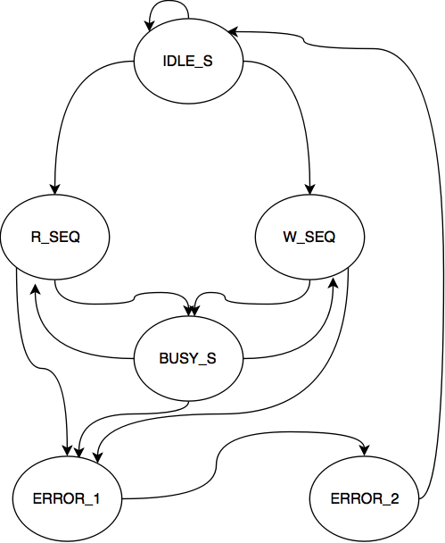
Figure 4.4: Finite state machine for memory controller

At raising edge of if HRESET is low then it will reset the data, address and control signals. At this time HREADY will be low to indicate master not to send data in next clock. If HREADY is high then master will send the address and control signals at raising edge of HCLK. Slave will sample that address and control signals at next clock and change its state according to control signal and address. If there is no transfer or master is in IDLE state then controller will be in IDLE_S state. In this state controller send the response HRESP OKAY and HREADY high indicating master that it is to receive transfer in next clock. If master sends some transfer then if address is in the range of connected memory chip then it will go to read or write state according to HWRITE signal. If it is a write then next state will be W_SEQ. memory controller will generate appropriate control signal for memory chip. It will generate chip select according to address and it is a write so it will enable write enable signal and output enable blocked. These signals are sampled by memory chip at memory clock cycle. If it is a read transfer then controller will go to R_SEQ state if there is not any error. In R_SEQ state it will provide the address to RAM and select the appropriate bank according to address and the data will be sampled by master at next clock of memory clock cycle. If there is any address which is not available in memory in any state then memory controller will go to error state and tell the master that there is an error by sending HREADY signal low. Master will reinitiate the transfer will correct address. For error handling slave need to send two clock responses in which first will be HREADY low and in second HREADY will be high. After two clock error slave will go into IDLE state. In R_SEQ or W_SEQ if there is any BUSY state then memory controller will go to in BUSY_S state and send HREADY signal to LOW. After BUSY_S state memory controller will go into read or write state according to HWRITE signal. The default state is IDLE state in which slave will send HREADY high to indicate the master that it is ready to transfer any data.

HRESETn
HCLK

AHB
Master

Memory
Controller
RAM

Memory
Bridge
RADDR

AHB
Slave
Bank-0
RWDATA
HWDATA
HADDR
CS-0
OE
HTRANS
WE
HSIZE
HBURST
RRDATA
HLOCK
HPROT
CS-1
Bank-1
HWRITE
HRESP
HRDATA
HREADY

OCLK
ECLK

Figure 4.5: Block diagram of AHB based memory controller
Memory Bridge will convert the AHB signals to memory readable format which is also introduced the interleaving. In read and write state if sampled address is synced with clock of RAM then there is no need of inserting HREADY low otherwise we need to insert HREADY low which will send memory controller to BUSY_S. For example if address is even and clock cycle for even clock is low then we can’t send data in next clock because of that we need to insert one wait state. For that master will extend its transfer to next clock. If it is an odd address then next clock is in favor of transfer so memory controller will go into R_SEQ or W_SEQ according to HWRITE signal. After first clock sync the data can be continuously read and write for single burst but if data it in single transfer then there can be wait state. This will introduce the concept of interleaving memory without using FIFO.
The specification of RAM is used from IBM static RAM Document. In which reading from memory will be done by sending appropriate control signals to RAM. To read a data from memory we need to first select correct memory bank. Before raising edge of memory clock chip select to be low, the address, write enable and output enable should be provided before clock edge. The data will be sample by memory controller after next raising edge of memory clock.

Figure 4.6: Memory Read cycle ^{[19]}

Writing a data to RAM we need to first select correct memory bank according to sampled memory address. The data, address and control signals like OE, WE, and CS will be sampled by memory at raising edge of memory clock. Memory needs at least on memory clock cycle to properly writing the data in memory bank. We cannot send another data and control signals in between memory cycle. While writing data chip select of appropriate bank should be low. The output enable signal should be high because it is active low cycle. The write enable signal should be low because it is active low signal.

Figure 4.7: Memory Write cycle ^{[19]}

Chapter - 5
Simulation and Synthesis Report

5.1 Simulation and Wave forms
The simulation of AHB based memory controller is done in Xilinx ISE software which is freely available for student. The Xilinx version used for simulation and synthesis is ISE (v 12.1) April 19, 2010 Integrated Synthesis Environment. This Xilinx tool is used to synthesis and analyzing timing performance of RTL design written in Verilog or HDL. There is ISIM simulator used for waveform analyzing which also comes with Xilinx package.

Write transaction wave forms (simulation results):
In this wave form first NONSEQ burst started with address 0x14(green color). Slave will sample the address and data after one clock cycle (Blue color).

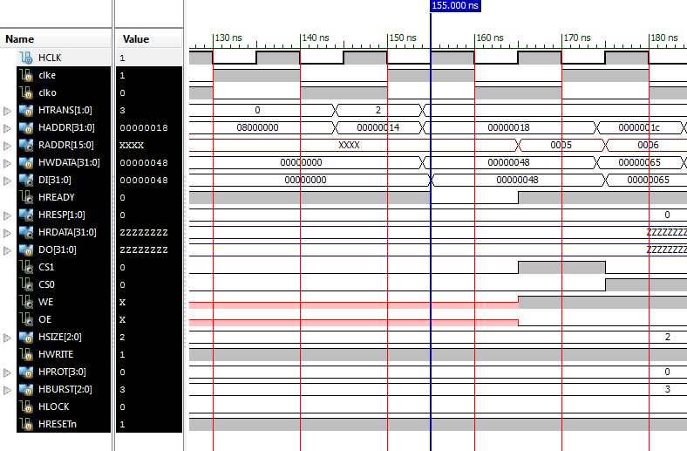
Figure 5.1: Write transaction wave forms – 1

In this wave form SEQ burst is continuous send the addresses (green color). Slave will sample the addresses and data in next cycle (Blue color).

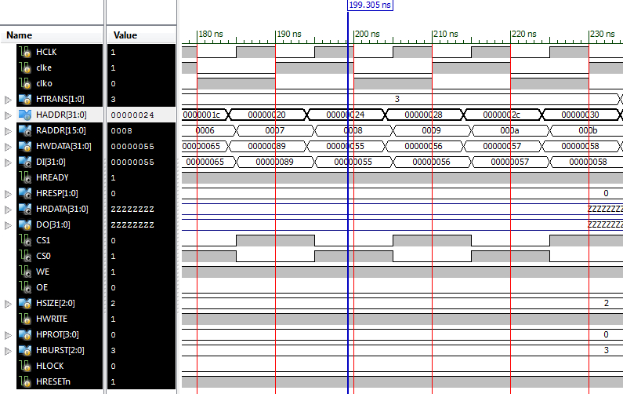
Figure 5.2: Write transaction wave forms – 2

In this wave form there is IDLE cycle send by master. In IDLE cycle chip select is no activated (Red rectangular).

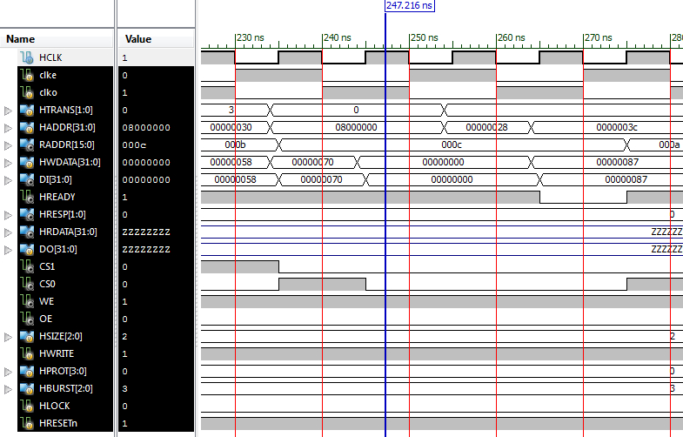
Figure 5.3: Write transaction wave forms – 3

In this wave form five NONSEQ signal burst are shown. Chip select is activated according to address. (Red Rectangular)

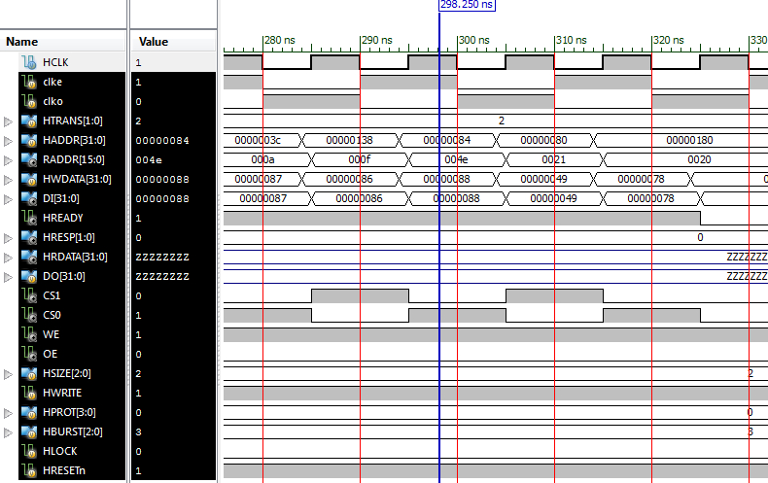
Figure 5.4: Write transaction wave forms - 4

In this wave form there is error because address 0x80000014 is not available. (Red Color)
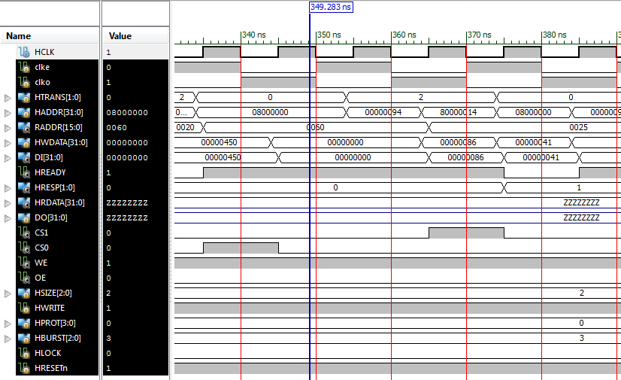
Figure 5.5: Write transaction wave forms - 5

Read transaction wave forms (simulation results):
In this wave form Read burst is started with address 0x14. Data will be sampled by master after two cycles. (Red color)

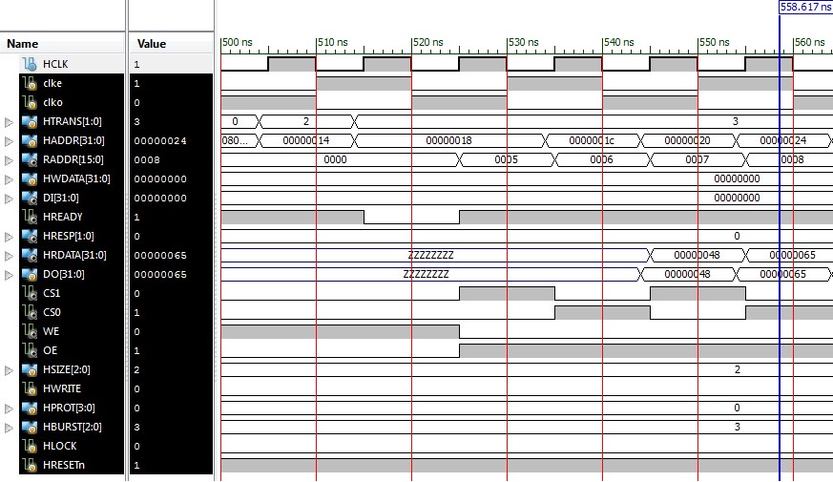
Figure 5.6: Read transaction wave forms - 1

In this wave form read burst is shown. Sequentially data are read from memory. (red color)
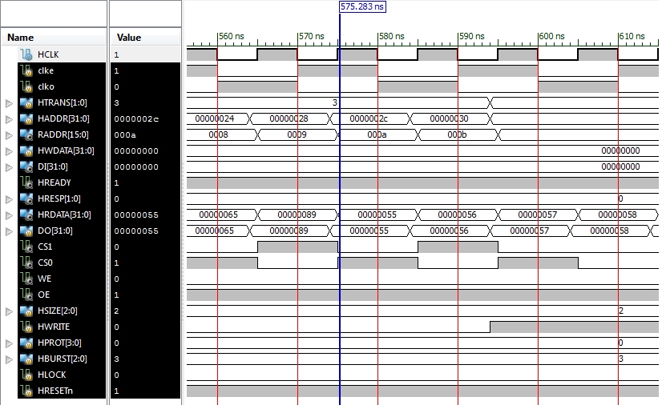
Figure 5.7: Read transaction wave forms - 2

5.2 Synthesis Report
Xilinx standard synthesis report for RTL design.
Project File: | mem.xise | Parser Errors: | No Errors
Module Name: | memc | Implementation State: | Synthesized
Target Device: | xc3s50-5pq208 | Errors: | No Errors
Product Version: | ISE 12.1 | Warnings:
Design Goal: | Balanced | Routing Results:
Design Strategy: | Xilinx Default (unlocked) | Timing Constraints:
Environment: | System Settings | Final Timing Score:

Table 5.1: Project status

Logic Utilization | Used | Available | Utilization
Number of Slice Registers | 86 | 768 | 11%
Number of Slice LUTs | 122 | 1536 | 7%
Number of fully used LUT-FF pairs | 156 | 1536 | 10%
Number of bonded IOBs | 191 | 124 | 154%
Number of BUFG/BUFGCTRLs | 1 | 8 | 12%

Figure 5.2: Synthesis report

Release 12.1 - xst M.53d (nt64)
Copyright (c) 1995-2010 Xilinx, Inc. All rights reserved.
--> Parameter TMPDIR set to xst/projnav.tmp
Total REAL time to Xst completion: 0.00 secs
Total CPU time to Xst completion: 0.27 secs

--> Parameter xsthdpdir set to xst
Total REAL time to Xst completion: 0.00 secs
Total CPU time to Xst completion: 0.27 secs

--> Reading design: memc.prj
TABLE OF CONTENTS
1) Synthesis Options Summary
2) HDL Compilation
3) Design Hierarchy Analysis
4) HDL Analysis
5) HDL Synthesis
5.1) HDL Synthesis Report
6) Advanced HDL Synthesis
6.1) Advanced HDL Synthesis Report
7) Low Level Synthesis
8) Partition Report
9) Final Report
9.1) Device utilization summary
9.2) Partition Resource Summary
9.3) TIMING REPORT
=========================================================================
* Synthesis Options Summary *
=========================================================================
---- Source Parameters
Input File Name : "memc.prj"
Input Format : mixed
Ignore Synthesis Constraint File : NO
---- Target Parameters
Output File Name : "memc"
Output Format : NGC
Target Device : xc3s50-5-pq208
---- Source Options
Top Module Name : memc

Analyzing hierarchy for module <memc> in library <work> with parameters.
BUSY = "01"
BUSY_S = "100"
ERROR_1 = "101"
ERROR_2 = "110"
IDEL = "00"
IDEL_S = "000"
NONSEQ = "10"
R_SEQ = "010"
SEQ = "11"
W_SEQ = "011"
=========================================================================
* HDL Analysis *
=========================================================================
Analyzing top module <memc>.
BUSY = 2'b01
BUSY_S = 3'b100
ERROR_1 = 3'b101
ERROR_2 = 3'b110
IDEL = 2'b00
IDEL_S = 3'b000
NONSEQ = 2'b10
R_SEQ = 3'b010
SEQ = 2'b11
W_SEQ = 3'b011
Module <memc> is correct for synthesis.

=========================================================================
* HDL Synthesis *
=========================================================================
Found 1-bit register for signal <CS0>.
Found 1-bit register for signal <CS1>.
Found 32-bit register for signal <DI>.
Found 32-bit register for signal <HRDATA>.
Found 2-bit register for signal <HRESP>.
Found 1-bit register for signal <OE>.
Found 16-bit register for signal <RADDR>.
Found 1-bit register for signal <WE>.
Found 32-bit register for signal <haddr_s>.
Found 32-bit register for signal <haddr_s2>.
Found 1-bit register for signal <hready_rnm0>.
Found 32-bit register for signal <hwdata_rnm0>.
Found 1-bit register for signal <hwrite_rnm0>.
Summary:
inferred 1 Finite State Machine(s).
inferred 184 D-type flip-flop(s).
Unit <memc> synthesized.
=========================================================================
HDL Synthesis Report
Macro Statistics
# Registers : 13
1-bit register : 6
16-bit register : 1
2-bit register : 1
32-bit register : 5
=========================================================================
=========================================================================
* Advanced HDL Synthesis *
=========================================================================
Analyzing FSM <FSM_0> for best encoding.
Optimizing FSM <curstate/FSM> on signal <curstate[1:3]> with gray encoding.
-------------------
State | Encoding
-------------------
000 | 000
010 | 110
011 | 010
100 | 011
101 | 001
110 | 111
-------------------
=========================================================================
Advanced HDL Synthesis Report
Macro Statistics
# FSMs : 1
# Registers : 152
Flip-Flops : 152
=========================================================================
=========================================================================
Final Register Report
Macro Statistics
# Registers : 154
Flip-Flops : 154
=========================================================================
* Final Report *
=========================================================================
Final Results
RTL Top Level Output File Name : memc.ngr
Top Level Output File Name : memc
Output Format : NGC
Optimization Goal : Speed
Keep Hierarchy : NO
Design Statistics
# IOs : 201
Cell Usage :
# BELS : 164
# GND : 1
# INV : 3
# LUT2 : 67
# LUT3 : 37
# LUT3_D : 1
# LUT3_L : 16
# LUT4 : 30
# LUT4_L : 2
# MUXCY : 5
# MUXF5 : 1
# VCC : 1
# FlipFlops/Latches : 154
# FD : 84
# FDC : 68
# FDS : 2
# Clock Buffers : 1
# BUFGP : 1
# IO Buffers : 190
# IBUF : 103
# OBUF : 87
=========================================================================
Device utilization summary:
---------------------------
Selected Device : 3s50pq208-5
Number of Slices: 86 out of 768 11%
Number of Slice Flip Flops: 122 out of 1536 7%
Number of 4 input LUTs: 156 out of 1536 10%
Number of IOs: 201
Number of bonded IOBs: 191 out of 124 154% (*)
IOB Flip Flops: 32
Number of GCLKs: 1 out of 8 12%

---------------------------
Partition Resource Summary:
---------------------------
No Partitions were found in this design.
---------------------------
=========================================================================
TIMING REPORT
NOTE: THESE TIMING NUMBERS ARE ONLY A SYNTHESIS ESTIMATE.
FOR ACCURATE TIMING INFORMATION PLEASE REFER TO THE TRACE REPORT
GENERATED AFTER PLACE-and-ROUTE.
Clock Information:
------------------
-----------------------------------+------------------------+-------+
Clock Signal | Clock buffer(FF name) | Load |
-----------------------------------+------------------------+-------+
HCLK | BUFGP | 154 |
-----------------------------------+------------------------+-------+
Asynchronous Control Signals Information:
----------------------------------------
-----------------------------------+------------------------+-------+
Control Signal | Buffer(FF name) | Load |
-----------------------------------+------------------------+-------+
HRESETn_inv(HRESETn_inv1_INV_0:O) | NONE(curstate_FSM_FFd1)| 68 |
-----------------------------------+------------------------+-------+
Timing Summary:
---------------
Speed Grade: -5
Minimum period: 4.802ns (Maximum Frequency: 208.236MHz)
Minimum input arrival time before clock: 6.514ns
Maximum output required time after clock: 7.212ns
Maximum combinational path delay: No path found
Timing Detail:
--------------
All values displayed in nanoseconds (ns)
=========================================================================
Timing constraint: Default period analysis for Clock 'HCLK'
Clock period: 4.802ns (frequency: 208.236MHz)
Total number of paths / destination ports: 286 / 75
-------------------------------------------------------------------------
Delay: 4.802ns (Levels of Logic = 3)
Source: hready_rnm0 (FF)
Destination: curstate_FSM_FFd3 (FF)
Source Clock: HCLK rising
Destination Clock: HCLK rising
Data Path: hready_rnm0 to curstate_FSM_FFd3
Gate Net
Cell:in->out fanout Delay Delay Logical Name (Net Name)
---------------------------------------- ------------
FDS:C->Q 53 0.626 1.736 hready_rnm0 (hready_rnm0)
LUT3:I2->O 1 0.479 0.704 curstate_FSM_FFd3-In20 (curstate_FSM_FFd3-In20)
LUT4_L:I3->LO 1 0.479 0.123 curstate_FSM_FFd3-In28 (curstate_FSM_FFd3-In28)
LUT4:I3->O 1 0.479 0.000 curstate_FSM_FFd3-In95 (curstate_FSM_FFd3-In)
FDC:D 0.176 curstate_FSM_FFd3
----------------------------------------
Total 4.802ns (2.239ns logic, 2.563ns route)
(46.6% logic, 53.4% route)
=========================================================================
Timing constraint: Default OFFSET IN BEFORE for Clock 'HCLK'
Total number of paths / destination ports: 243 / 132
-------------------------------------------------------------------------
Offset: 6.514ns (Levels of Logic = 5)
Source: HTRANS<1> (PAD)
Destination: curstate_FSM_FFd1 (FF)
Destination Clock: HCLK rising
Data Path: HTRANS<1> to curstate_FSM_FFd1
Gate Net
Cell:in->out fanout Delay Delay Logical Name (Net Name)
---------------------------------------- ------------
IBUF:I->O 68 0.715 2.045 HTRANS_1_IBUF (HTRANS_1_IBUF)
LUT4:I0->O 1 0.479 0.000 curstate_FSM_FFd1-In461 (curstate_FSM_FFd1-In461)
MUXF5:I0->O 1 0.314 0.976 curstate_FSM_FFd1-In46_f5 (curstate_FSM_FFd1-In46)
LUT2:I0->O 1 0.479 0.851 curstate_FSM_FFd1-In63_SW0 (N50)
LUT4:I1->O 1 0.479 0.000 curstate_FSM_FFd1-In75 (curstate_FSM_FFd1-In)
FDC:D 0.176 curstate_FSM_FFd1
----------------------------------------
Total 6.514ns (2.642ns logic, 3.872ns route)
(40.6% logic, 59.4% route)
=========================================================================
Timing constraint: Default OFFSET OUT AFTER for Clock 'HCLK'
Total number of paths / destination ports: 86 / 86
-------------------------------------------------------------------------
Offset: 7.212ns (Levels of Logic = 1)
Source: hready_rnm0 (FF)
Destination: HREADY (PAD)
Source Clock: HCLK rising
Data Path: hready_rnm0 to HREADY
Gate Net
Cell:in->out fanout Delay Delay Logical Name (Net Name)
---------------------------------------- ------------
FDS:C->Q 53 0.626 1.677 hready_rnm0 (hready_rnm0)
OBUF:I->O 4.909 HREADY_OBUF (HREADY)
----------------------------------------
Total 7.212ns (5.535ns logic, 1.677ns route)
(76.7% logic, 23.3% route)
=========================================================================
Total REAL time to Xst completion: 9.00 secs
Total CPU time to Xst completion: 9.01 secs
-->
Total memory usage is 244636 kilobytes

Chapter – 6
Conclusion and future work

6.1 Conclusion
The memory controller is successfully designed and implemented. Bus protocol for design used is AMBA AHB bus protocol. This protocol is most popular protocol used nowadays in industry help to make design portable and reusable. Previously used FIFO based memory controller will lack in latency. But introducing concept of interleaving will reduce the latency in system and increase the throughput. This will significantly increase the performance of memory controller. The wave form for read and write of a data show that memory controller working according to its specification. The critical path delay can be found in synthesis report generated from Xilinx design tool ISE. Number of LUTs used in design can also found in synthesis report which will be indication for area used for design.
In FIFO based AHB memory controller initially FIFO is empty after transfer begins master will start filling data and commands in FIFO. After some time FIFO will be full. Master will wait for FIFO to become empty. This will introduce bubble or stall in system. ^{[1]} After compare with FIFO based AHB memory controller it has been seen that there is need to accommodate FIFO circuit in SoC. And the maximum frequency for FIFO based memory controller is 155.67MHz (Critical path delay is 6.425ns). ^{[1]} Now comparing with Interleaved AHB based memory controller the maximum frequency is 208.236 MHz and critical path delay is 4.80 ns can be referred in synthesis report in chapter 5. This is significantly improvement in terms of speed.
6.2 Future work
The memory controller can be made n-way interleaving by increasing number of banks in memory. We can also make parameterized memory controller. Instant of using AHB protocol we can use AXI bus protocol which can increase more bandwidth for system. Memory control can also be made independent of what type of memory will be connected with memory controller.

Bibliography

[1] Ramagundam, Shashisekhar et al. "Design And Implementation Of High-Performance Master/Slave Memory Controller With Microcontroller Bus Architecture". 2014 IEEE International Instrumentation and Measurement Technology Conference (I2MTC) Proceedings (2014): n. pag. Web. 27 June 2017.

[2] Shobha R Hadimani ,Panchami , (2015) " Verilog Based Design Of High Performance Data Access Amba Memory Controller " , International Journal of Management and Applied Science (IJMAS) , pp. 88-91, Volume-2, Issue-5

[3] Rishabh Singh Kurmi, Shruti Bhargava and Ajay Somkuwar. Article:Design of AHB protocol block for Advanced Microcontrollers. International Journal of Computer Applications 32(8):23-29, October 2011. Full text available. BibTeX

[4] C. Sharma, Archana. "Construct High-Speed SDRAM Memory Controller Using Multiple FIFO's For AHB Memory Slave Interface". International Journal of Emerging Technology and Advanced Engineering volume 3.Issue 3 (2013): 1-10. Web. 28 June 2017.

[5] https://soc.eecs.yuntech.edu.tw/Course/SoC/doc/amba.pdf

[6] "Read-Only Memory". En.wikipedia.org. N.p., 2017. Web. 28 June 2017.

[7] Khalifa, Khaled et al. "Memory Controller Architectures: A Comparative Study". 2013 8th IEEE Design and Test Symposium (2013): n. pag. Web. 11 June 2017.

[8] Rao, Shilpa. "Testing Of AMBA Compliant Memorycontroller Using Pattern Generator/ Logicanalyser". Rroij.com. N.p., 2017. Web. 26 June 2017.

[9] "What Is Hard Disk Drive (HDD)? - Definition From Whatis.Com". SearchStorage. N.p., 2017. Web. 26 June 2017.

[10] "What Is SSD (Solid-State Drive)? - Definition From Whatis.Com". SearchSolidStateStorage. N.p., 2017. Web. 26 June 2017.

[11] "Memory (RAM) And Its Influence On Performance". Computermemoryupgrade.net. N.p., 2017. Web. 27 June 2017.

[12] "Static Random-Access Memory". En.wikipedia.org. N.p., 2017. Web. 28 June 2017.

[13] "Read Write Processor Bus Cycles". Eventhelix.com. N.p., 2017. Web. 28 June 2017.

[14] "Memory Controller". En.wikipedia.org. N.p., 2017. Web. 28 June 2017.

[15] "ARM | Corelink DMC-520 Dynamic Memory Controller". ARM | The Architecture for the Digital World. N.p., 2017. Web. 28 June 2017.

[16] "Advanced Microcontroller Bus Architecture". En.wikipedia.org. N.p., 2017. Web. 28 June 2017.

[17] "AMBA Open Specifications - ARM". Arm.com. N.p., 2017. Web. 28 June 2017.

[18] https://www.cs.vassar.edu/~jones/Stallings/E-InterleavedMemory.pdf

[19] https://www.ece.cmu.edu/~ece548/localcpy/sramop.pdf

[20] En.wikipedia.org. (2017). Memory hierarchy. [online] Available at: https://en.wikipedia.org/wiki/Memory_hierarchy [Accessed 29 Jun. 2017].

